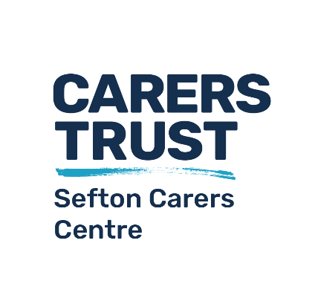
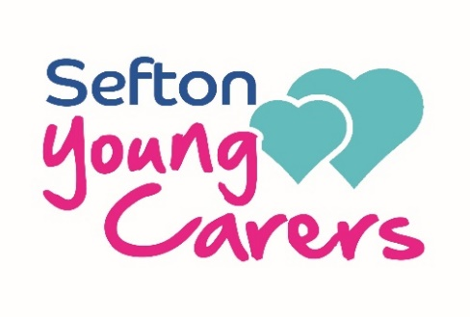

Young Carer Referral Form

We encourage you to contact us on 0151 288 6060 or at yc@carers.sefton.gov.uk for informal discussions about possible referrals.

This referral form is to be used for young carers aged 5 to 17. Young adult carers aged between 18 and 24 can be referred using the Sefton Carers Centre adult carer referral form.

Who are young carers?
Young carers care for a friend or family member who, due to illness, disability, a mental health problem or a substance misuse issue, cannot cope without their support.

Young carers are responsible for providing support to the person they care for, such as:

- Practical Cleaning, cooking, laundry, paying bills, collecting prescriptions
- Physical Lifting and moving, responsible for shopping for food
- Personal Assisting in bathing, washing, dressing, feeding, medication
- Emotional Listening, comforting, coping with mood changes
- Sibling care Helping them to dress, cooking meals, homework help, taking to school

Pre-Referral Checklist
Consider the following points before proceeding with this referral:
- Is the young person aged between 5 and 17?
- Does the young person and/or the person they care for live in Sefton?
- Does the young person have caring responsibilities?
- Has the young person been spoken with about being referred as a young carer?
- Has parental consent been given for the referral to be made?
- Does the person in need of care have an illness, a disability, a mental health problem or a substance misuse issue?

Referral Process
- New referral received and allocated to a staff member
- Contact made with referrer and parent
- Introductory meeting with the young person arranged, normally taking place in school
- Discussion of the young person’s caring role and their needs
- Explanation of our services and the work we do with and for young carers in Sefton
- Discussion of the introductory meeting with staff team and actions agreed
- Referrer, family and young person informed of outcome
- If agreed, young person will be registered as a young carer and can access support
- If not eligible, other support options will be discussed

Proceed to completing the form if you are satisfied that this young person is a young carer.

Consent
Has consent been given by all parties below for this referral to be made and data to be shared? Without consent, please do not complete the rest of this form.

The Young Person
Name:
Date of birth:
Phone number:
Address:
Gender: |  |  | Language:
Language / communication support needs:
School:
School contact:
Young person’s own conditions / needs (if any):

The Caring Role and Responsibilities
Diagnosis / condition of the cared for person:
Relationship to young person:
Hours caring: | 0-12 |  |  | 12-24 |  | 25+
Support given to cared for person: | Practical e.g. cooking, cleaning, laundry, prescription collection
 | Physical e.g. lifting and moving, food shopping
 | Personal e.g. bathing, washing, dressing, feeding, medication
 | Emotional e.g. listening, comforting, coping with mood changes
 | Sibling e.g. school runs, cooking, dressing, homework, bed-time
Description of caring responsibilities:
Others who help to care:

Impacts of the Caring Role
Does your caring role negatively affect you in any of the following areas?
Your mental health and wellbeing
Your physical health and lifestyle
Your family relationships and home-life
Your education
Your free time (your time for yourself to take a break and have fun)
Note: The referrer / parent must not answer these questions on behalf of a young person.

The Parent / Guardian
Name:
Phone number:
Address:
Email:

The Referrer
Name:
Phone number:
Email:
Organisation:

Other Information
In the box below please indicate your reasons for making this referral and your concerns for the young person.
Additionally, include any other relevant information about the young person or family, including any risk indicators.
Details of any other agencies or professionals working with the young person and/or the family should also be shared, stating names, job roles, and contact details wherever possible.

Completed referral forms should be emailed to yc@carers.sefton.gov.uk wherever possible.

