**Personal Health Budget Pre-Paid Card**

**What is a pre-paid card?**

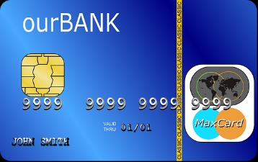 **It works like a bank card**

**You can use it to pay for the services, equipment or facilities you use to meet your assessed needs**

**How it works**

**Your Personal Health Budget will be paid onto a card.**

**The card can be used to pay for services, equipment or facilities by using,**

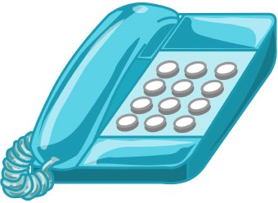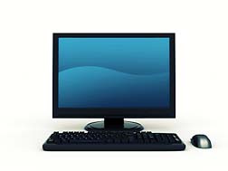

Telephone Banking

Internet Banking

**You can check to see how much money you have**

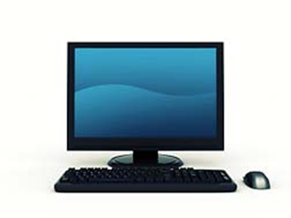 **On the internet On the telephone**

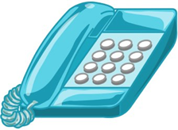

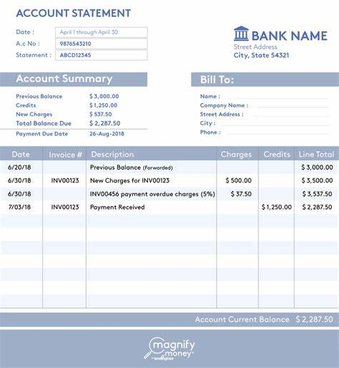

**You can also print a paper copy telling you what you have spent**

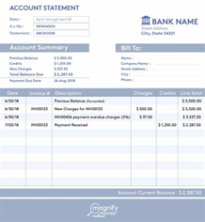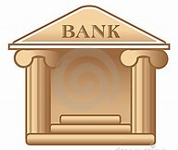

**You do not need to open a bank account**

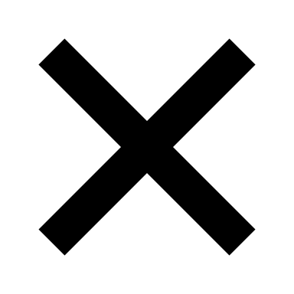

**You do not have to send any bank statements to the Personal Health Budget Support Service**

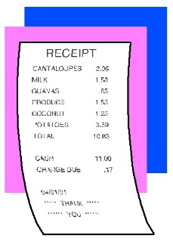

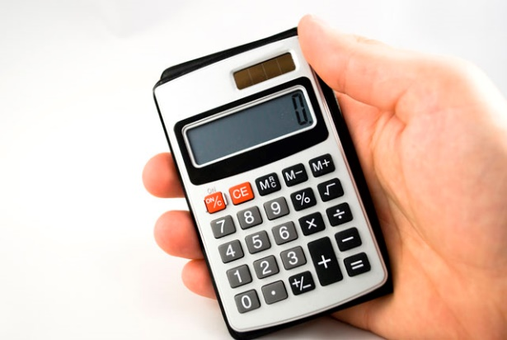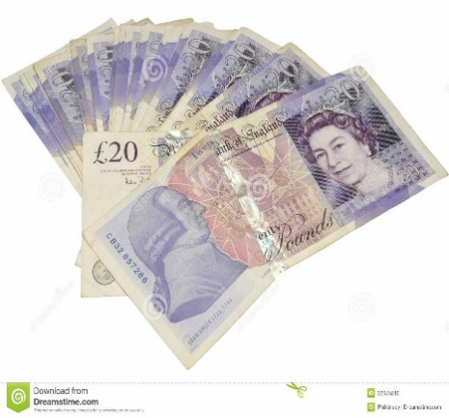

**If you have any questions**

**Ask your Personal Health Budget Adviser for more information by contacting the service on:**

**Helen Vernon PHB Lead (0151) 288 6110**

**Helen Saunders PHB Adviser (0151) 288 6111**

**It will be easier to manage your budget**

**You can check to see how much money you have any time you want to**

**The Personal Health Budget Support Service will still require invoices, receipts and timesheets on a regular basis**