Direct Payments Team
Sefton Carers Centre
27-37 South Road
Waterloo
L22 5RF

Date: Mar-20
Please contact: Payroll Section Contact Number: 0151 288 6074/7/9
Email: dppayroll@sefton.gov.uk

Dear Employer,

Update-Important Payroll Information relating to Covid-19(Coronavirus)

We recently contacted you with information relating to the Covid-19(coronavirus) outbreak, please visit the following link for this information: https://www.sefton-carers.org.uk/index.php/direct-payments

Due to the ongoing advice from the government and UK health authorities, Sefton Carers Centre will be closed to drop in visitors. This is to ensure safety of our staff and to our clients.

Due to staff working from home and potential staff shortages there may be some delays in providing a full payroll service from 23/03/20.

Please see below details of how this may affect you as an employer and steps you can take to reduce any difficulties that may arise:

- There may be delays in payslips being issued on time for pay day, to try to minimise this we are immediately registering all employers that we hold email addresses for with open space and will be issuing their payslips electronically. We will continue to issue paper wage slips for those employers who do not have email addresses

- DBS –ID verification. We will verify ID via Skype where possible. Please contact us if this will cause you any difficulties, if you need DBS verification for a new employee to commence urgently, contact your social worker or Sefton plus for advice on 0345 140 0845

- Potential delays in us answering phone calls or responding to phone messages/reply to emails promptly.
If possible, please email dppayroll@sefton.gov.uk with your queries/changes to hours worked etc. If you are unable to email, leave a message on one of the numbers above. We will respond to you, if needed, as soon as we can.

- If wage slips do not arrive by pay day, we suggest you take the following action:
- if you usually pay the same contracted hours, pay the normal basic net pay
-If there has been changes to the contracted hours, pay the normal basic net pay and make any adjustments when you receive the payslip-
-if an overpayment is made you can correct on the next wage payment
-If your employee is paid varied hours, please telephone payroll who will be able to provide the details
If you have updated your email address or you have never provided one and want to receive electronic wage slips please email payroll by Friday 27th March. This will reduce the chance of delayed payslips in the post. For other benefits, please visit the following link: https://www.sefton-carers.org.uk/index.php/payroll-information
Please email dppayroll@sefton.gov.uk to request this.

- If you usually contact us to make payments on your behalf to your employee/s via your pre-paid card account:
Please contact your Direct Payment advisor by telephone or email, if a member of the team is not available, please contact the Pre-paid card support service (PFS) on 0207 127 0754 as they are also able to make payments on your behalf.

We would like to thank you, at this challenging time, for your understanding and support over the coming weeks/months. We will continue to keep you updated of any changes to our payroll service as soon as possible.

For more information and to keep updated on Covid-19 (coronavirus) please visit the following sites:
www.gov.uk
https://www.nhs.uk/conditions/coronavirus-covid-19/

(18/03/20) Important Payroll Information relating to Covid-19 (Coronavirus)

As you are aware due to the fast-moving situation regarding covid-19(coronavirus) we are facing unprecedented times. Like many businesses across the UK, we are closely monitoring the outbreak and following the advice by the government and UK health authorities.

Currently, our payroll department is open as normal. We will inform you promptly if there are any changes due to the likelihood of a reduced payroll service or in the event of Sefton Carers centre closing. In these circumstances we will provide advise to ensure your employees are still paid.

Please see below advise regarding issues you may have as an employer, if you need any further guidance please check the government website www.gov.uk or contact your employer’s insurance company with issues relating to pay.

Can my employee come to work if we both have no coronavirus symptoms?
We advise at this time, employment can carry on as normal if there are no coronavirus symptoms with yourself, your household, your employee/s and their household.

Will my employee be paid if they are off sick or must self-isolate?
Under these circumstances your employee would not be paid, they would use one of the following:
- You would need to check your employee’s contract of employment regarding sick pay terms. Most employees would be entitled to statutory sick pay (if eligible).
- Unpaid sick leave if not eligible for statutory sick pay
- Holiday pay
- Unpaid leave
- Payment in lieu (employee would need to make this time back up)

Will my employee be paid if I am sick or need to self-isolate?
If your employee can come to work and you ask them not to come in due to you not being well/self-isolating, then they would be entitled to full pay during this period.

How do I get cover if my employee is off sick/self-isolating?
- Do you have another carer who could provide support temporarily?
- Can a family member provide informal support?
- Contact an agency
- Contact Sefton council on 0345 140 0845

For more information, please see our guidance below, you can also visit the following NHS website for coronavirus symptoms and how to help minimise infection:

https://www.nhs.uk/conditions/coronavirus-covid-19/

Kind regards
Direct Payments Payroll Team

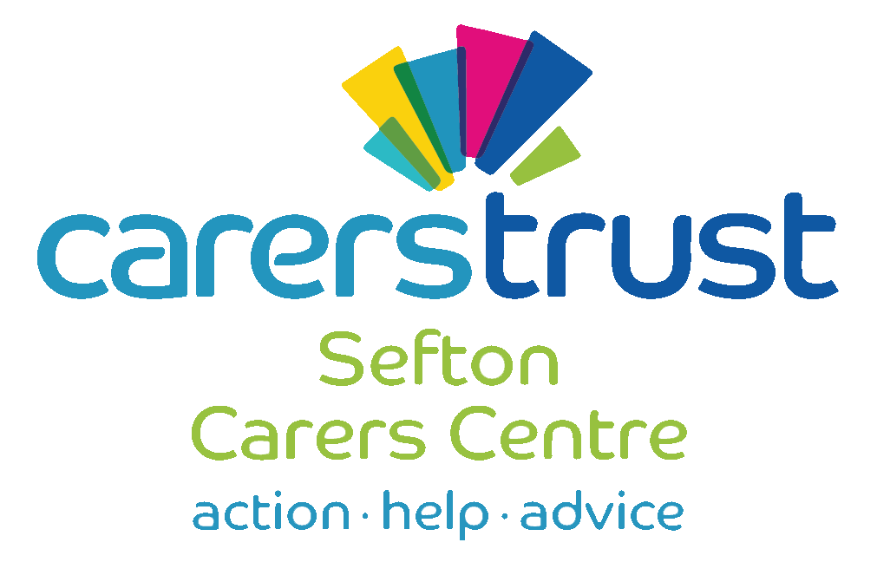

Coronavirus
Information for:
- Carers
- Cared for
- People using a care agency
- People employing a Personal Assistant
General precautions
- Wash your hands frequently with soap and water or use alcohol-based sanitizer
- Ask anyone visiting your home to wash their hands when they arrive and when they leave, before and after personal care and at regular intervals
- Ask them if they have any of the symptoms (persistent cough and/or temperature in excess of 37.5)
- Keep property properly ventilated by opening windows whenever safe and appropriate.
If you use an agency
Speak to the agency about what contingency plans they have and follow the general precautions mentioned above.
If you employ personal assistants
- Speak to your insurance provider for advice
- Notify payroll if your staff are unwell and unable to work. They may be entitled to Statutory Sick Pay if eligible
- If you instruct your worker not to visit, they are entitled to full pay
- If you are worried about planning your care, please contact the Direct Payment or Personal Health Budget advisers but please be aware there are a high volume of calls at this time

If your loved one is in residential or nursing care

- Follow the guidance regarding hand washing and self-isolation
- Maintain contact via telephone
- Speak to the care home about their contingency planning
- If you are aged over 70 or with a pre-existing health condition you should consider social distancing

If you become unwell and need to self-isolate:

- plan ahead and ask others for help to ensure that you can successfully stay at home
- for those with personal assistants ask your employee to help you get the things you need to stay at home
- stay at least 2 metres (about 3 steps) away from other people in your home if possible
- sleep alone, if possible
- wash your hands regularly for 20 seconds, each time using soap and water, or use hand sanitiser
- stay away from vulnerable individuals, such as the elderly and those with underlying health conditions, as much as possible
- you do not need to call NHS 111 to go into self-isolation. If your symptoms worsen during home isolation or are no better after 7 days, contact NHS 111 online. If you have no internet access, call NHS 111. For a medical emergency dial 999
Coping with self-isolation and social distancing
- Minimize watching, reading or listening to news that causes you to feel anxious or distressed;
- seek information only from trusted sources
- Mind have advice about coping with isolation:
https://www.mind.org.uk/information-support/coronavirus-and-your-wellbeing/#collapsef968c
Carers Emergency Card – this is scheme is run by Sefton Carers Centre. To register please visit the website www.sefton-carers.org.uk

If you have a GP appointment for something that is not related to the coronavirus, please call to check that you are still able to attend.
In working hours
Sefton Carers Centre 0151 288 6060
Sefton Plus 0345 140 0845
Out of hours
Social Services 0151 934 3555
District Nurse South Sefton – 0151 247 6933
Community Emergency Response Team (CERT) for Southport and Formby
01704 387262
Silverline 0800 4 70 80 90
www.sefton-carers.org.uk
www.sefton.gov.uk
www.carers.org
This document referred to the following sources for information:
https://www.gov.uk/government/publications/covid-19-residential-care-supported-living-and-home-care-guidance
https://www.gov.uk/government/publications/covid-19-stay-at-home-guidance

