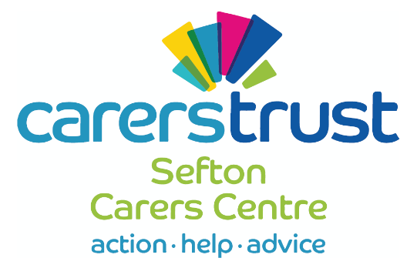
EDF2
Private and Confidential
Personal Health Budget
New PA Starter Form

Employer Name:
Mr/Mrs/Miss/Ms/other
Employer Address:
Postcode:
Client’s Name (if different):

Employer’s NI Number:
Employer’s Email Address:

Employee Name:
Mr/Mrs/Miss/Ms/Other
Employee Address:

Postcode:
Employee’s NI Number:
Date of Birth:
Employee’s Email Address:
Bank Account Name:
Account No |  | Sort Code | - -

Employment Details |  | Start/Amended Date
No of Hours per week |  |  |  |  |  |  | No of sleepovers per week
Rate per hour |  | £ |  |  |  |  | Rate per sleepover |  |  |  |  |  | £
Hours per day/ working days |  | M |  | T |  | W |  |  | T |  | F |  |  | S |  | S
Sleepovers per day/ working days |  | M |  | T |  | W |  |  | T |  | F |  |  | S |  | S
Employee Statement:
Please circle only one of the following statements.
A | This is my first job since 6th April and I have not received any taxable allowances, benefits or pensions
B | This is now my only job but since last 6th April I have had another job, or received taxable allowances or incapacity benefit. I do not receive a state or occupational pension
C | As well as this job, I have another job or receive a state or occupational pension

Disclosure and Barring Service (DBS)
Prior to registering your employee on payroll we require them to complete a DBS form online. To complete the form, you need to email PHB@sefton.gov.uk and mark the email ‘Payroll’.
Your employment cannot start until DBS clearance has been received by the PHBSS
Privacy Notice
As your Employer, I will process the above personal information as it is necessary to perform a contract; this information will be held to enable me to adhere to the requirements of your employment contract including pay, Inland Revenue and pension contributions.
When required, I will share your information with the Personal Health Budget Support Service, NEST Pension Fund, HMRC and other organisation in relation to the obligation or processing your wage payments.
Sefton Personal Health Budget Support Service and I will hold your Personal Information for a maximum period of 6 years after the end of your employment. All information will be destroyed after that date.
Payslips will be sent to you by electronically unless agreed with the Personal Health Budget Support Service.

I confirm that all details given in this form are accurate and up to date. I will complete a new form should my personal information need to be amended.
Employee’s Signature:

Date:
By signing this declaration, you are agreeing that you read and understood the following responsibilities
- The Personal Health Budget Team cannot authorise the use of additional hours unless we receive confirmation of agreement from the community health care team.
- You must ensure that your Employee is paid the National Minimum Wage for hours worked, details of the current rates can be found at www.gov.uk/national-minimum-wage-rates

Employer’s Signature:

Date:
This form must be returned to: Personal Health Budget Support Service, Sefton Carers Centre,27-37 South Road, Waterloo L22 5PE

