Electronic Payslips
Guide

Contents

What are Electronic Payslips? 2
How do I get started on IRIS OpenSpace? 2
How do I view my employee payslips? 4
What if a payslip is incorrect? 5
Further Information 7
Contact Details 7

What are Electronic Payslips?

Every four weeks, the Payroll Team will produce payslips for any employees that have worked during the four-week period outlined in the payroll schedule. These Payslips will be uploaded to an account set up specifically for you to access through a website called IRIS OpenSpace.

How do I get started on IRIS OpenSpace?

You will be notified via email that an account has been set up for you by the Payroll Team. Open the email and click the activation link.

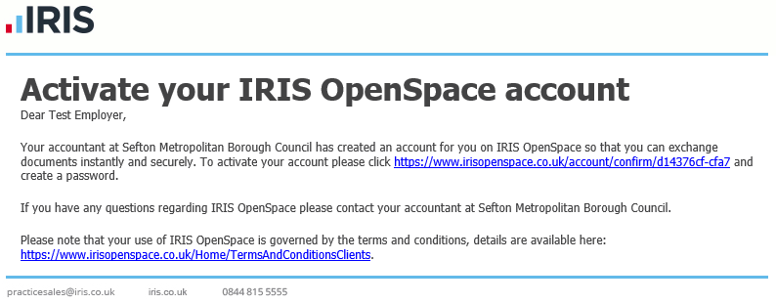

The link will direct you to www.irisopenspace.co.uk where you will be asked to create a strong password for your account. The password you choose will be securely stored by IRIS OpenSpace and only you will have access to this password. Once you have decided on a password, click Set Password.

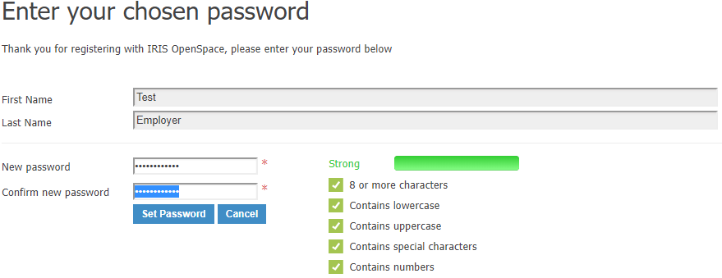

Now that you have set up a password, you will be redirected to the log-in page. Enter your email address and the password you have just created. Click Login.

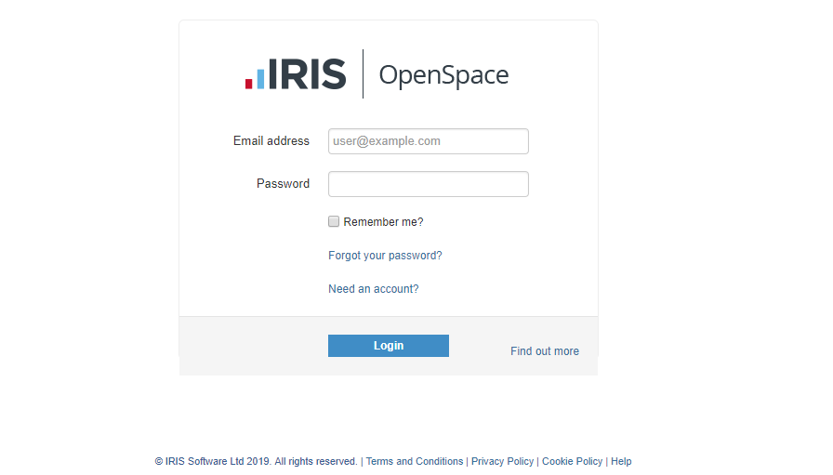

Once you’ve logged in and agreed to the Terms & Conditions, you will be able to view your IRIS OpenSpace dashboard. This is the page where you’ll be able to see any files (i.e. Payslips) that have been sent to you.

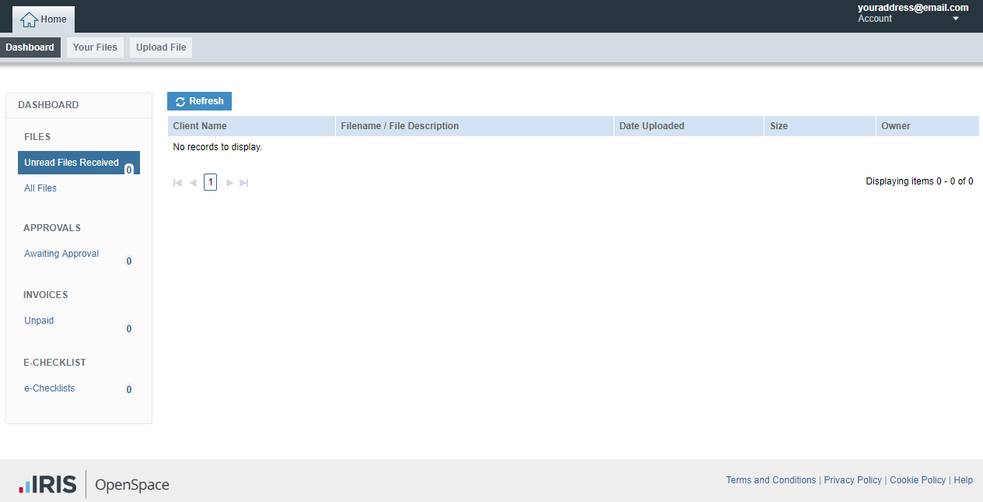

How do I view my employee payslips?

Once the Payroll Team have uploaded any payslips to your account, you will receive an email informing you that a file has been added. Open the email and click the link to the file.

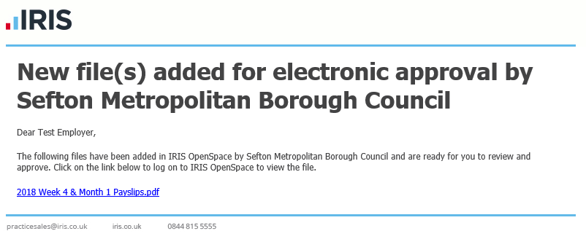

You should now be redirected to IRIS OpenSpace and instructed to login. Once logged in, click the folder ‘Files From Sefton Metropolitan Borough Council’.

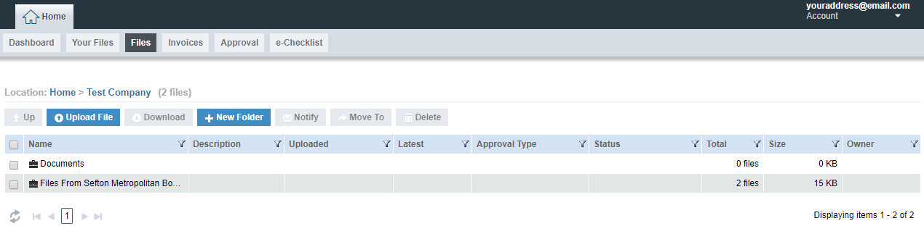

In this folder, you should see a file with ‘payslip’ in the title. Click the file to open a PDF version of the payslip.

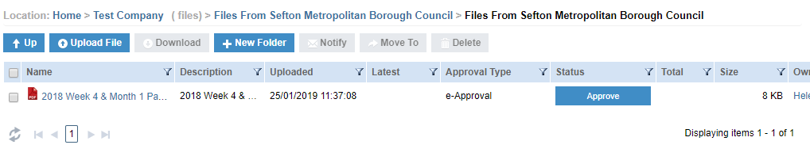

What if a payslip is incorrect?

Once viewed, you will have the option to approve or reject a payslip. Click the approve button next to where the file is located.

If you are happy that the payslip is correct, click Approve. If you think the payslip is incorrect and will need to be amended, click Reject.

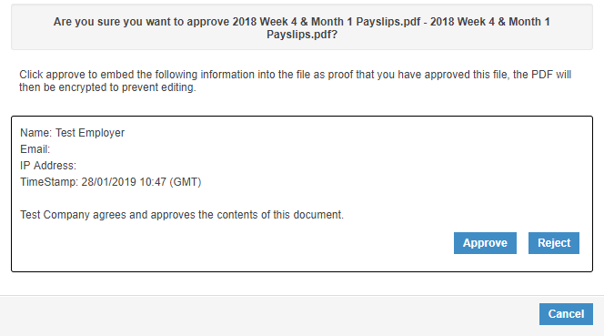

If the file has been approved, this action will now be displayed alongside the file and no further action is required.

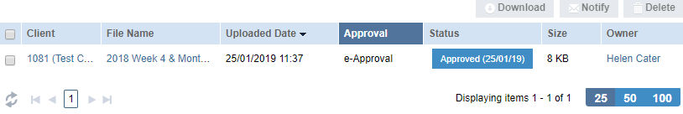
If rejected, please tell us the reasons why in the comment box and of amendments that need to be made. Click Reject and the Payroll Team will be informed of these comments and be able to make amendments to any incorrect payslips.

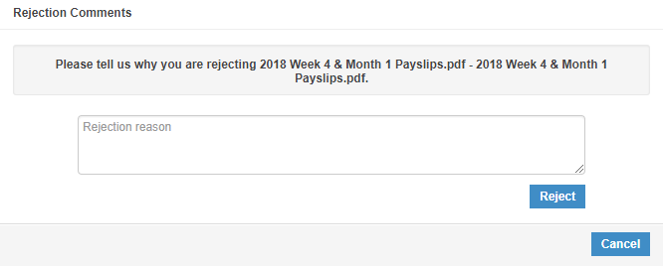

Regardless of whether you have approved or rejected the payslip, you will still be able to see all documents that have been sent to you. To see these files, go to your IRIS OpenSpace dashboard and click All Files.

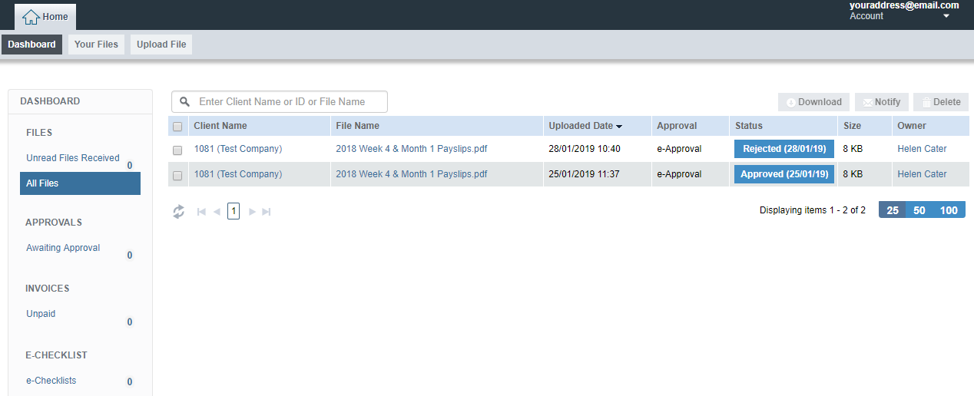

Further Information

- If you have forgotten your password, this can be reset via the login page. Click on ‘Forgot your password?’ and enter your email address. You’ll then receive an email allowing you to change your password.

- If you have an issue relating to your OpenSpace account then you should contact the Payroll Team, not IRIS.

- Do not change the email address connected with IRIS OpenSpace without informing the Payroll Team first.

- It is your responsibility to pass any payslips to your employees. You can either download payslips from OpenSpace and email them to your employees or print.

Contact Details

If you have any queries or issues about IRIS OpenSpace and/or any files you receive then please contact a member of the Payroll Team.
Tel: 0151 288 6074
Tel: 0151 288 6077
Tel: 0151 288 6079
Email: DPPayroll@sefton.gov.uk

